**Assignement 7**

RITA FADLALLAH

**Question 1**

Provide a summary of the main concepts that went through about solar radiation

* **What is solar radiation?**

Solar radiation, often called the solar resource, is a general term for the electromagnetic radiation emitted by the sun. The spectrum of solar radiation is close to that of a black body. Solar radiation can be captured and turned into useful forms of energy, such as heat and electricity, using a variety of technologies. However, the technical feasibility and economical operation of these technologies at a specific location depends on the available solar resource.

Because the Earth is round, the sun strikes the surface at different angles, ranging from 0° (just above the horizon) to 90° (directly overhead). When the sun's rays are vertical, the Earth's surface gets all the energy possible. The more slanted the sun's rays are, the longer they travel through the atmosphere, becoming more scattered and diffuse.

**The three main components of solar radiation are the direct, the diffused and the reflected solar radiation.**

* 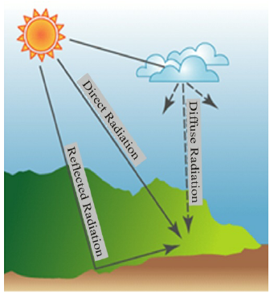**Direct solar radiation**

The solar radiation that reaches the Earth's surface without being diffused is called direct beam solar radiation. They are absorbed by the earth’s surface and warm it. Solar radiation reaching any spot on Earth depends on:

* Geographic location
* Time of day
* Season
* Local landscape
* Local weather
* **Diffuse solar radiation**

As sunlight passes through the atmosphere, some of it is absorbed, scattered, and reflected by:

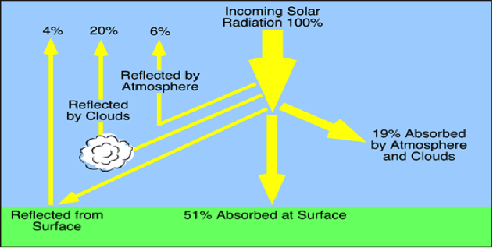

* Air molecules
* Water vapor
* Clouds
* Dust
* Pollutants
* Forest fires
* Volcanoes

This is called diffuse solar radiation. The sum of the diffuse and direct solar radiation is called **global solar radiation**. Atmospheric conditions can reduce direct beam radiation by 10% on clear, dry days and by 100% during thick, cloudy days.

Direct radiation is an unobstructed direct line from the sun. Diffuse radiation is scattered by atmospheric constituents, such as clouds and dust.

* **Reflected solar radiation**

Any object that can absorb radiation will also reflect some of that radiation. This is the reason why, from space, Earth appears bright and glowing, reflecting away some of the Sun's light. Earth's albedo = the amount of radiation reflected, is about 30% of the total incoming radiation from the Sun. The other 70% of the radiation is absorbed. The reflected radiation simply bounces off of Earth's atmosphere and is re-emitted into space.

**Question 2**

Create a pdf file with screenshots of all of the steps we went through in the second lesson on OpenStudio and explain briefly the reason behind the use of each step.

**Step 1:** Set weather to Piacenza

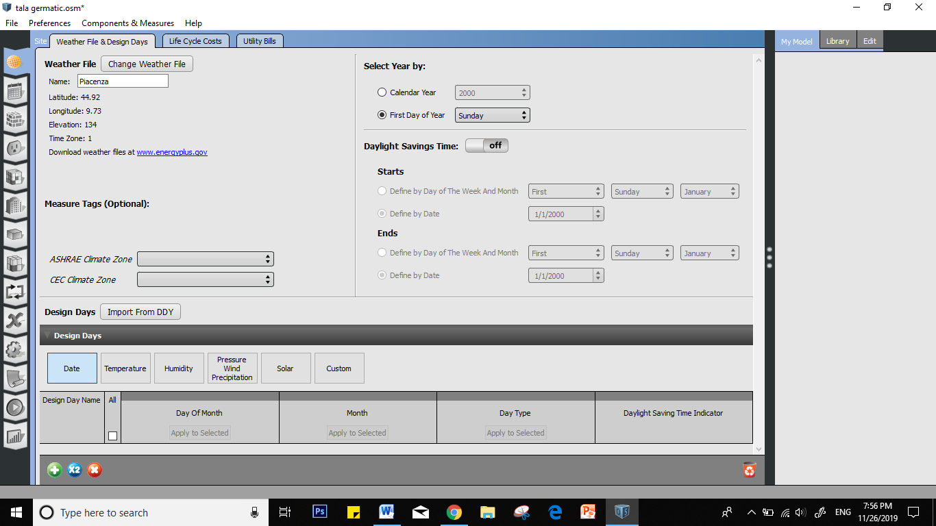

**Step 2:** Go to “Construction” and duplicate the current item and rename to “customization 1”

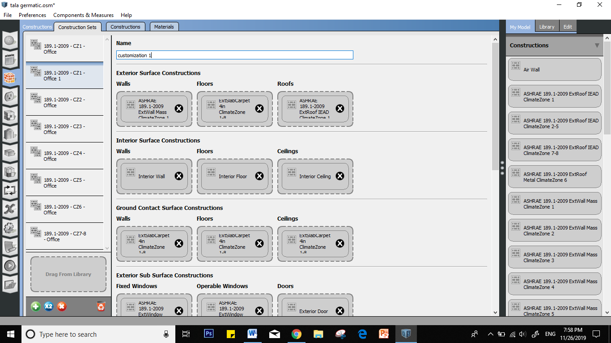

**Step 3:** Click on “constructions” tab and duplicate it then rename it “custom 1”. Change the “intended surface type” to “exterior wall” and the “standard construction type” to “mass”

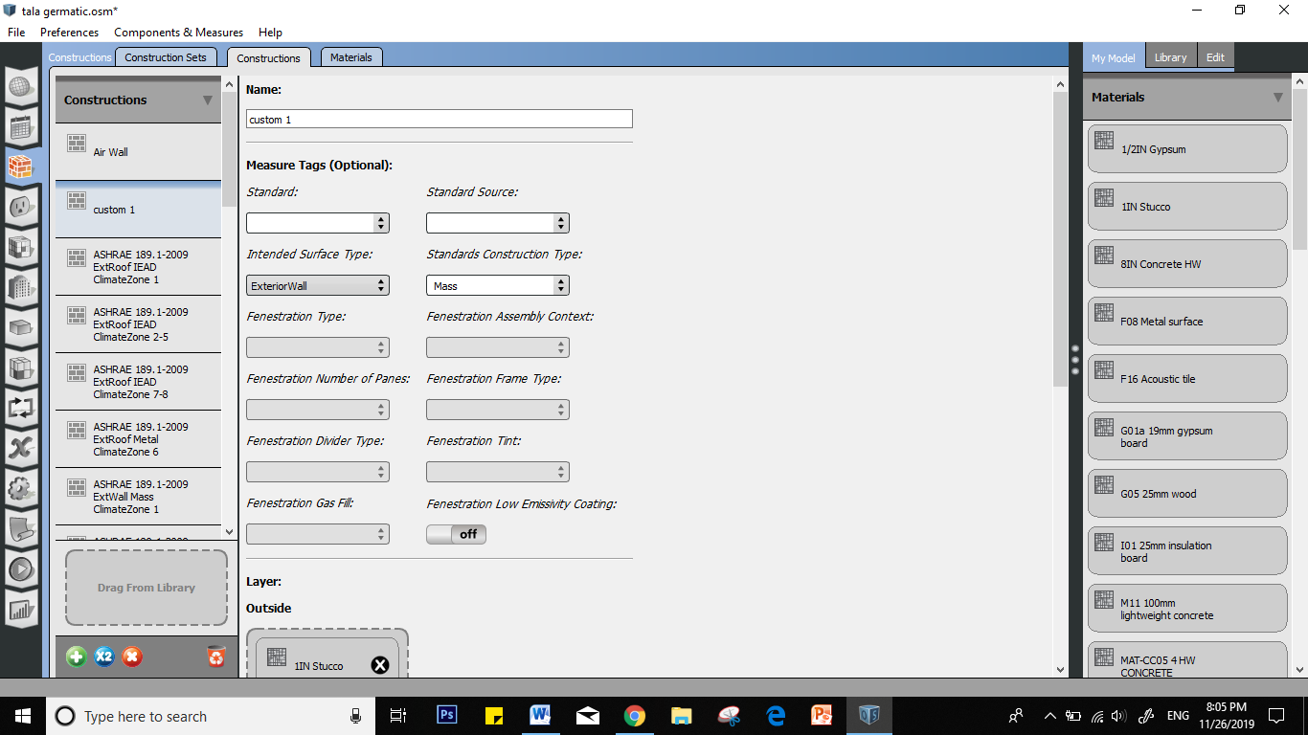

**Step 4:** delete the existing layer in layers and add the layers below in the follow order

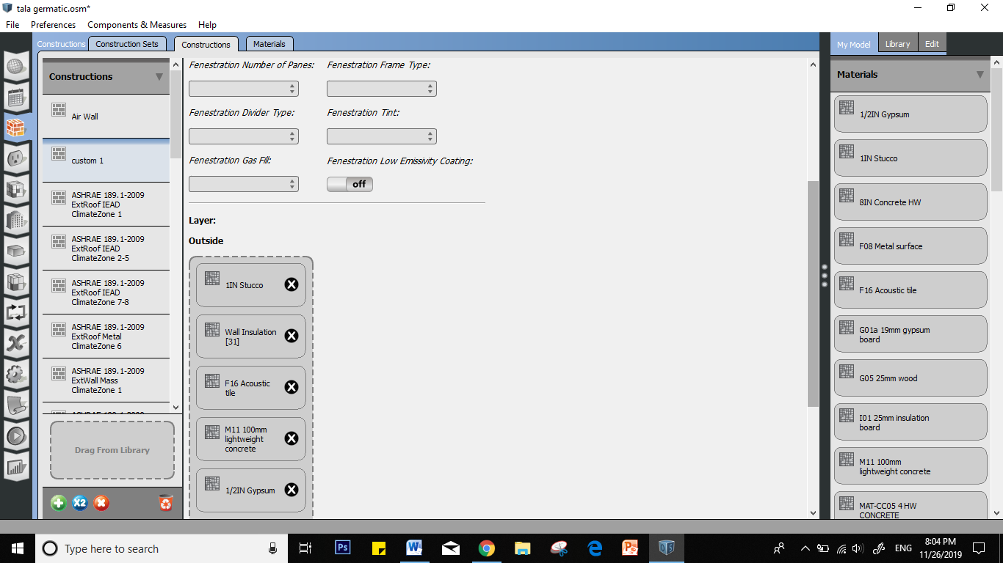

**Step 5:** go to “materials” to check the materials properties

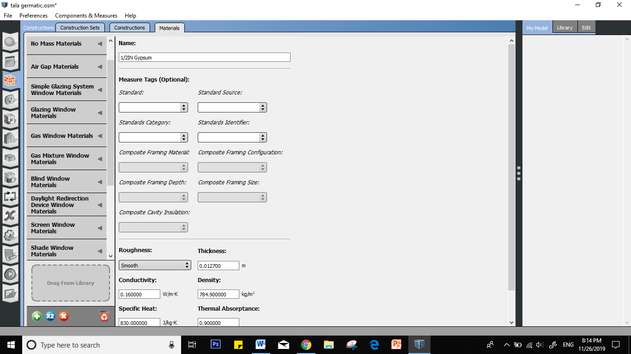

**Step 6:** go to the “materials” column and duplicate the material the adjust the properties according to the numbers below

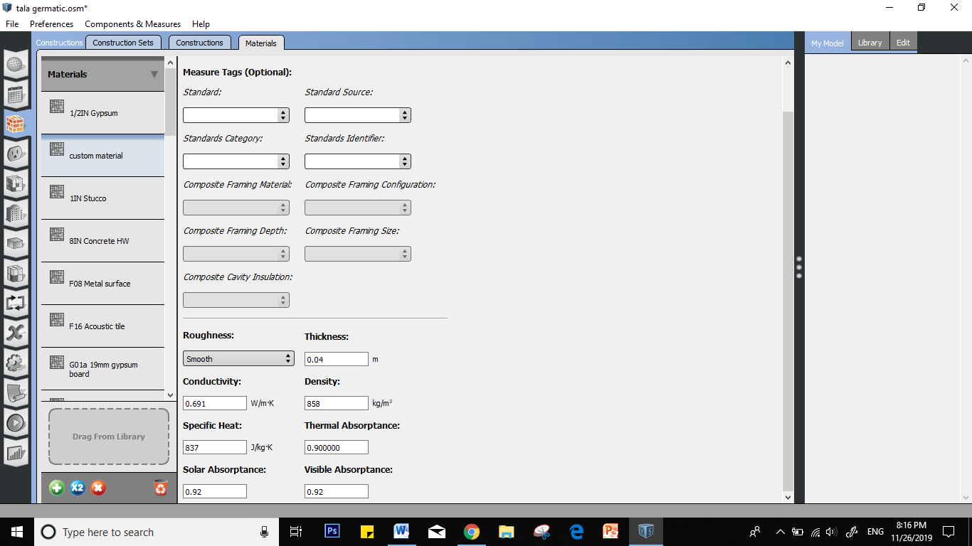

**Step 7:** go to: construction sets” then to the new custom layer and drag the newly created material in the “exterior surface constructions” layers

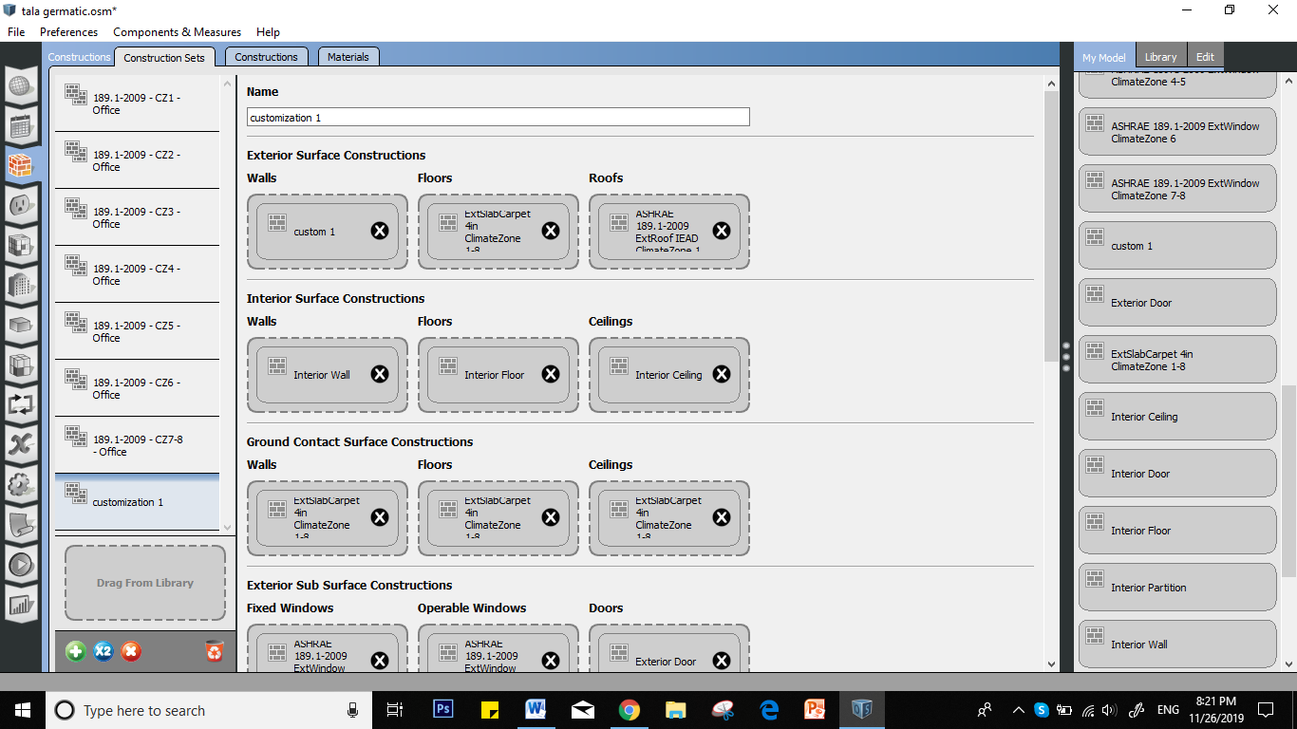

**Step 8:** go to “spaces” and select all the layers to apply the properties over all the floors

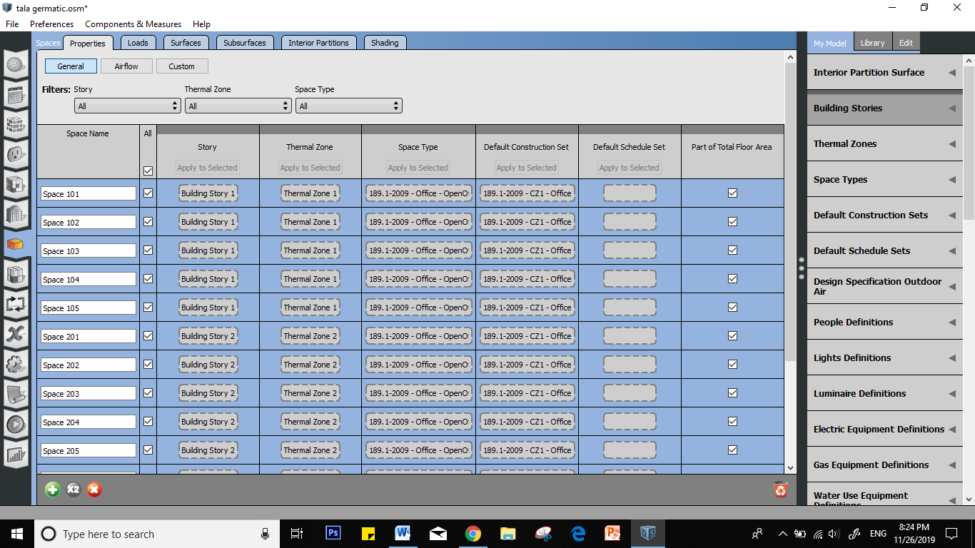

**Step 9:** go to the “schedule” icon and duplicate the layer then go to “schedules” tab to obtain the visualization.

